# **Login to GitHub,**

# **Create a Repository:** A repository is usually used to organize a single project. Repositories can contain folders and files, images, videos, spreadsheets, and data sets – anything your project needs

### To create a new repository

# In the upper right corner, next to your avatar or identicon, click and then select **New repository**.

# Name your repository hello-world.

# Write a short description.

# Select initialize this repository with a README.

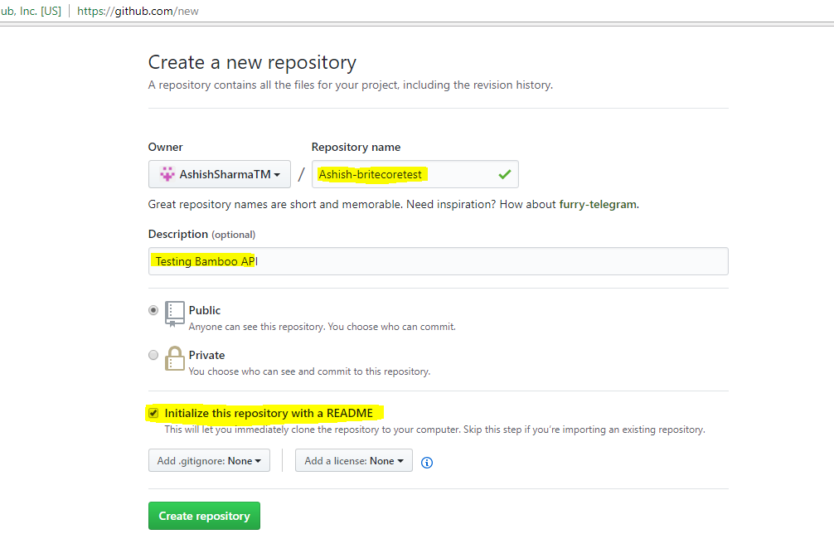Click **Create repository**.

## Step 2. Create a Branch.

**Branching** is the way to work on different versions of a repository at one time.

By default our repository has one branch named master which is considered to be the definitive branch. We use branches to experiment and make edits before committing them to master.

When you create a branch off the master branch, you’re making a copy, or snapshot, of master as it was at that point in time. If someone else made changes to the master branch while you were working on your branch, you could pull in those updates.

This diagram shows:

* The master branch
* A new branch called feature (because we’re doing ‘feature work’ on this branch)
* The journey that feature takes before it’s merged into master

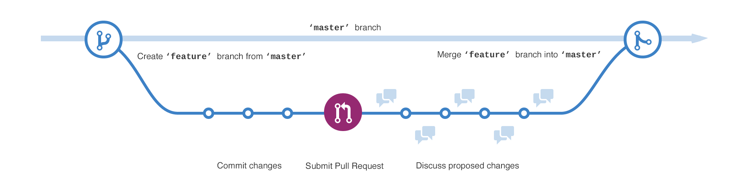

Branches accomplish similar goals in GitHub repositories.

Here at GitHub, developers, writers, and designers use branches for keeping bug fixes and feature work separate from our master (production) branch. When a change is ready, they merge their branch into master.

### To create a new branch

1. Go to your new repository hello-world.
2. Click the drop down at the top of the file list that says **branch: master**.
3. Type a branch name, readme-edits, into the new branch text box.
4. Select the blue **Create branch** box or hit “Enter” on your keyboard.